Adding HTTP redirect feature in windows 2008

Windows Server 2008 or Windows Server 2008 R2

1. On the taskbar, click **Start**, point to **Administrative Tools**, and then click **Server Manager**.
2. In the **Server Manager** hierarchy pane, expand **Roles**, and then click **Web Server (IIS)**.
3. In the **Web Server (IIS)** pane, scroll to the **Role Services** section, and then click **Add Role Services**.
4. On the **Select Role Services** page of the **Add Role Services Wizard**, expand **Common Http Features**, select **HTTP Redirection**, and then click **Next**.  
   [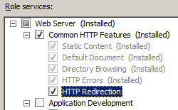](https://docs.microsoft.com/en-us/iis/configuration/system.webserver/httpredirect/index/_static/image5.png)
5. On the **Confirm Installation Selections** page, click **Install**.
6. On the **Results** page, click **Close**.

Re-directing a subfolder

1. Open the IIS manager. Open the Run dialog (Windows+R), type inetmgr and press Enter. You will need Adminstrator privileges for this.
2. Select the sub-folder within your website in the left pane (by clicking on the folder name) and then open HTTP Redirect in the main view. 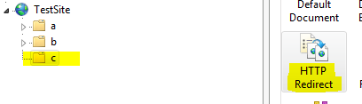
3. Select Redirect requests to this destination and type in your destination domain name http://www.domain2.com/. Check the other options (if they are applicable to you) and click Apply to save. 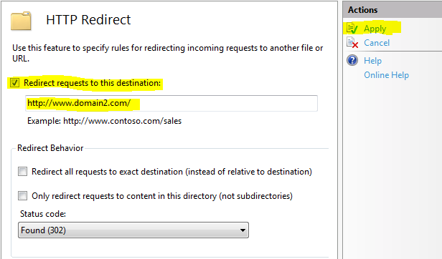
4. Check the redirection in your browser.